How to become a member of APhA-ASP
New member:
- Go to pharmacist.com
- Under membership tab, select join APhA-ASP
  - Scroll down and select join now
- Make an account
  - Use student Campbell email!!
- Select Student
  - Select: I am in my first professional degree program
- You will come to this page:
  - Fill out the information
  - Selecting Campbell for institution and put in your graduation year
- Continue through each step filling out the information as completely as possible
- Payment at the end should be $55 dollars
  - $10 dollars for the chapter
  - $45 for national
- Complete payment

Renewing membership:
- Go to pharmacist.com
- Log into account
- Under membership tab
  - Select renew membership
- Once new page loads, select renew now
  - It may ask you to log in again
- Once logged in, select student pharmacist
- Make sure information is current
- Select next
  - This will be the screen you will see.
  - Make sure the information is correct
  - You can choose to auto renew if you would like
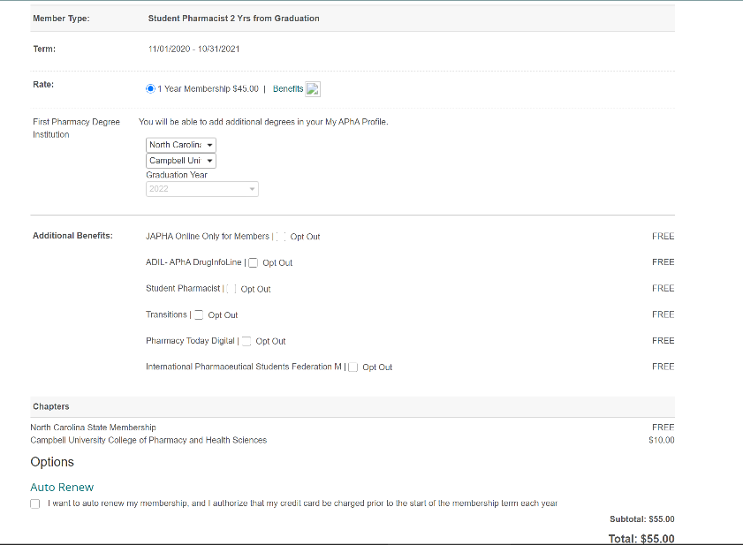
  - Scroll down and select next
- Academies, Section, and SIGs page will come up
  - Make sure ASP is your primary academy – can add addition interest groups and academies if you like
    - Click Save
- Next section, any contribution that you may like to make you can.
  - Select next
- Review and finalize your information
  - Select pay now
  - Put in card information
  - And pay now

  - $120 that includes your final year as student pharmacist and your first year as a New Practitioner!
  - Enroll by October 31st to receive NAPLEX study tool benefits!
  - $120 that includes your final year as student pharmacist and your first year as a New Practitioner!
  - Enroll by October 31st to receive NAPLEX study tool benefits!

