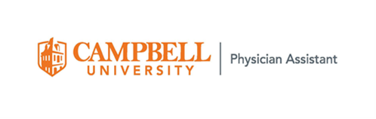

LETTER OF GOOD STANDING

Date: June 27, 2022
From: Campbell PA Clinical Team

Fax: 910-814-5567

Student name: ADD YOUR NAME
Graduation Date: July 14, 2023
Clinical Year: July 25, 2022- July 15, 2023

Please accept this letter as verification that the above named student from the Campbell University Physician Assistant Program has completed the following requirements and is eligible to participate in clinical rotations:

- Currently in good standing with the Physician Assistant Program and Campbell University after completion of the didactic year.
- Completed Core orientation training to include HIPAA and blood borne pathogen training (refresher completed April 2022).
- Current BLS (October 2021) and ACLS (March 2022) certification.
- Malpractice insurance coverage through Campbell University Physician Assistant Program (COI available upon request).
- Personal health insurance.
- Successful completion of a Criminal Background Check & Substance Abuse Screen (completed June 2021 & June 2022) – results available upon request.
- Currently up to date with all immunizations.

