Come grab some breakfast and experience Black History!
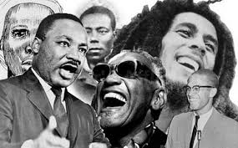

Black History Month Celebration!
When: Friday February 18@ 8:30AM
Where: Room 114

