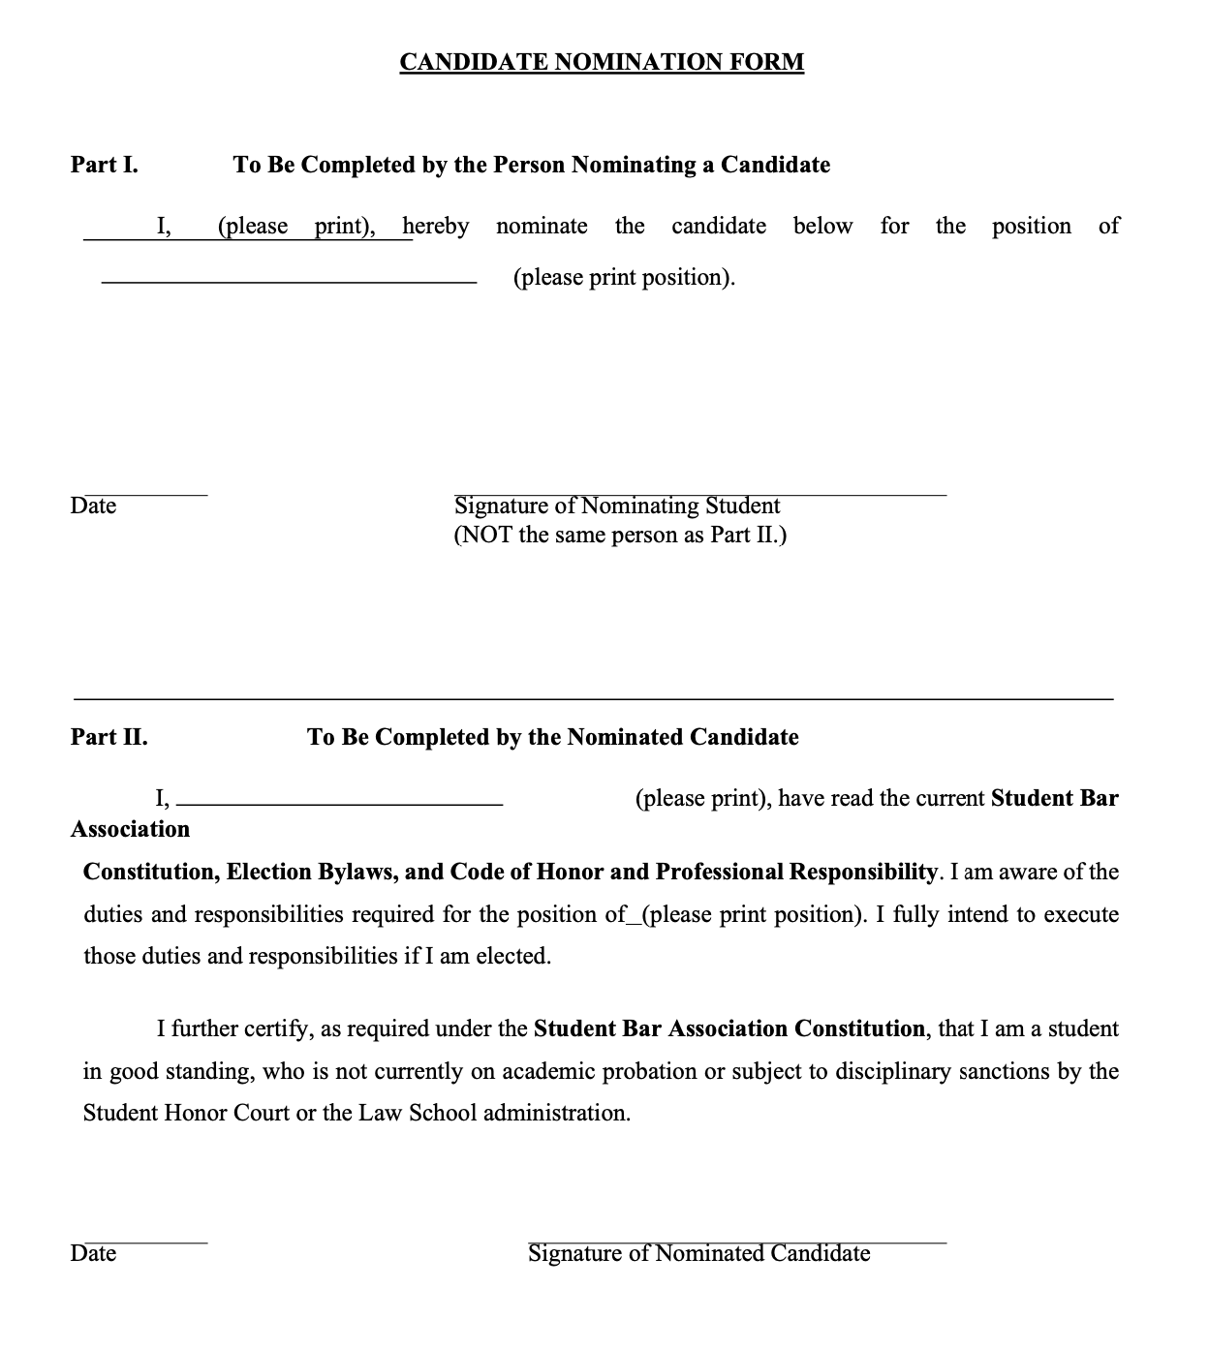

Candidate Statement
Each nominated candidate may submit a statement of 500 words or less describing the candidate’s goals, experience, campaign philosophy, or other information relevant to the candidate or campaign. The SBA Election Committee shall compile the nominated candidate statements and email the nominated candidate statements to the student body before the polls open. If a nominated candidate submits a statement as described above, such statement is not considered an “unsolicited electronic communication” as described in Article IV, Section 6. If you are interested in submitting a Candidate Statement, please type it below.

